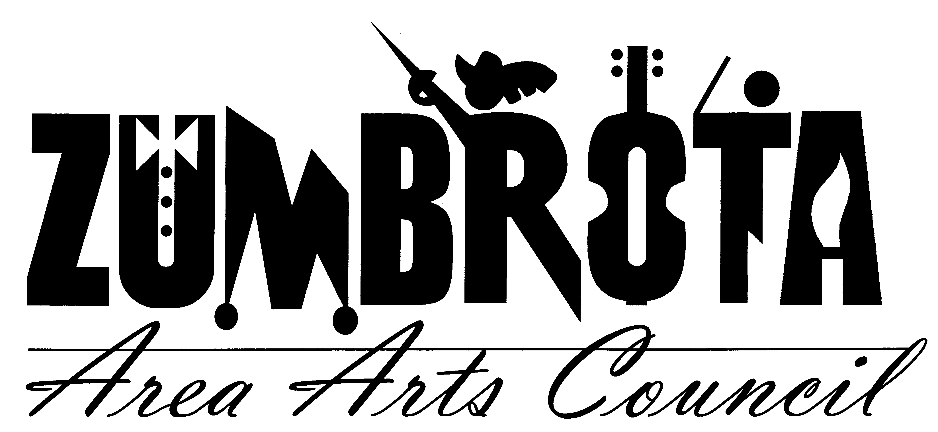
July 2, 2012 7:00 PM
Zumbrota Library
Meeting Minutes

In Attendance: Pam Shaw, Faye Joyner, Cheryl Hill, Allan Nilson, Dave Zimmerman, Marit Lomen, Bill Marx, Joan Hellyer, Ronda Sand, Marie Marvin, Sue Wedge

Call to Order: President Pam Shaw called the meeting to order and welcomed guests Marie and Sue.

Agenda

8 the Play
Sue Wedge discussed the Sheldon Theatre interest in performing 8 the play at the State Theatre. The Board had several questions regarding financial aspects and responsibilities of involved parties. Sue agreed to get that information and provide it to the Board. The Board agreed they would vote on 8 the Play via email after more information was received. Sue left the meeting.

ASCAP Fees & Equipment
Marie Marvin was present to discuss the ASCAP fees for the State Theatre. Marie negotiated the price down to 836 dollars for both the State Theatre and Crossings for a 2 year agreement. For an additional 385 dollars we can hold recordings of live concerts. Marie also discussed her purchase of a soundboard for use at the theatre for 500 dollars. The Soundboard would have been 2100 new. The theatre needs another snake and some other equipment. Marie stated she is going to purchase equipment as need and will keep us informed. Marie Marvin left the meeting.

The board discussed the equipment situation and decide as equipment is purchased ZAAC’s will determine what the contribution will be. Board voted and agreed that ZAAC will pay ½ of the ASCAP fees. Allen motioned and Joan 2nd that ZAAC will purchase the Soundboard from Marie.

Art in East Park
Faye reported that there were 2 more vendors for Art in East Park than last year. There was more traffic in the afternoon than the morning. Faye also reported some grumbling with some of the vendors as to things they were not happy about. Many of the vendors reported that the turnout was lower than expected. Faye also reported that she has redone the mailing list for Art in East Park as it hasn’t been done since 1999. Faye also agreed to continue to run Art in East Park, but needs help.

Theatre Movie
Z theatre actors showed 101 Dalmatians on the Friday of the Covered Bridge Festival. 120 to 150 people attended and 190 dollars in concessions was raised. The Board agreed this was good family programing and we should do more, but keeping in mind that we may need to cover licensing fees.

Iron Pour
8 Tiles have been sold so far. Tiles can be purchased at Crossings. Savage Aural Hotbed sent their equipment requirements and their contract. Joan has placed this paperwork into the ZAAC Dropbox.com folder. A grant to cover up to 5k of the Iron Pour cost has been submitted to SELCO as part of the Library Legacy grant.

Financial Report
Dave reported that there is 5611.14 dollars in the regular ZAAC fund. There is 68, 376.44 dollars in the Theatre fund. ZAAC received 17k in donations and also received a 3k matching grant from SEMAC for a projector. The Freewheelers concert brought in 1420 dollars in tickets, 507 dollars in profit after band and concessions.

Theatre Reports
Roof – Dave reported he has talked to and ask Merl Edel to look at the roof and he says he will soon.
3.2 license – Dave filled out an application to sell strong beer.
Dehumidifier – Bill set up and got the dehumidifier running in the basement.
Email – An email was sent to ZAAC regarding Z theatre actors’ performance costumes, Ronda agreed to contact the sender and try to organize the costumes.
Projector – James Hill is working on getting a projector into the theatre using the 3k matching.
Policy regarding Theatre usage – Al will send out the policy again and the board should be looking to approve it at the next meeting.
The Board discussed a beer garden and licensing and insurance for the Iron Pour but no decision was made.

Membership
Bill and Joan are working on a membership meeting for early October.
There are currently 75 regular memberships and 120 from Encore. Bill still has some CDs to send to the Phone-a-thon people.

Art Splash
Art Splash will have tours of theatre at 11 and 1pm. Ronda agreed to conduct the tours.

Music in the Park
Music in the park will have 4 more performances in July. The Board discussed the Ice Cream usage. Cheryl Reported that attendance has been good. Ellen Mittelstadt will be available in July to help with the concerts.

Ronda had several questions for the board, regarding email, website access, Historical information about the theatre, newsletter, setting up the telephone, some questions about some financial information, a request to get a credit card.

The meeting was adjourned at 917 pm.

Respectfully submitted,
Cheryl Hill

