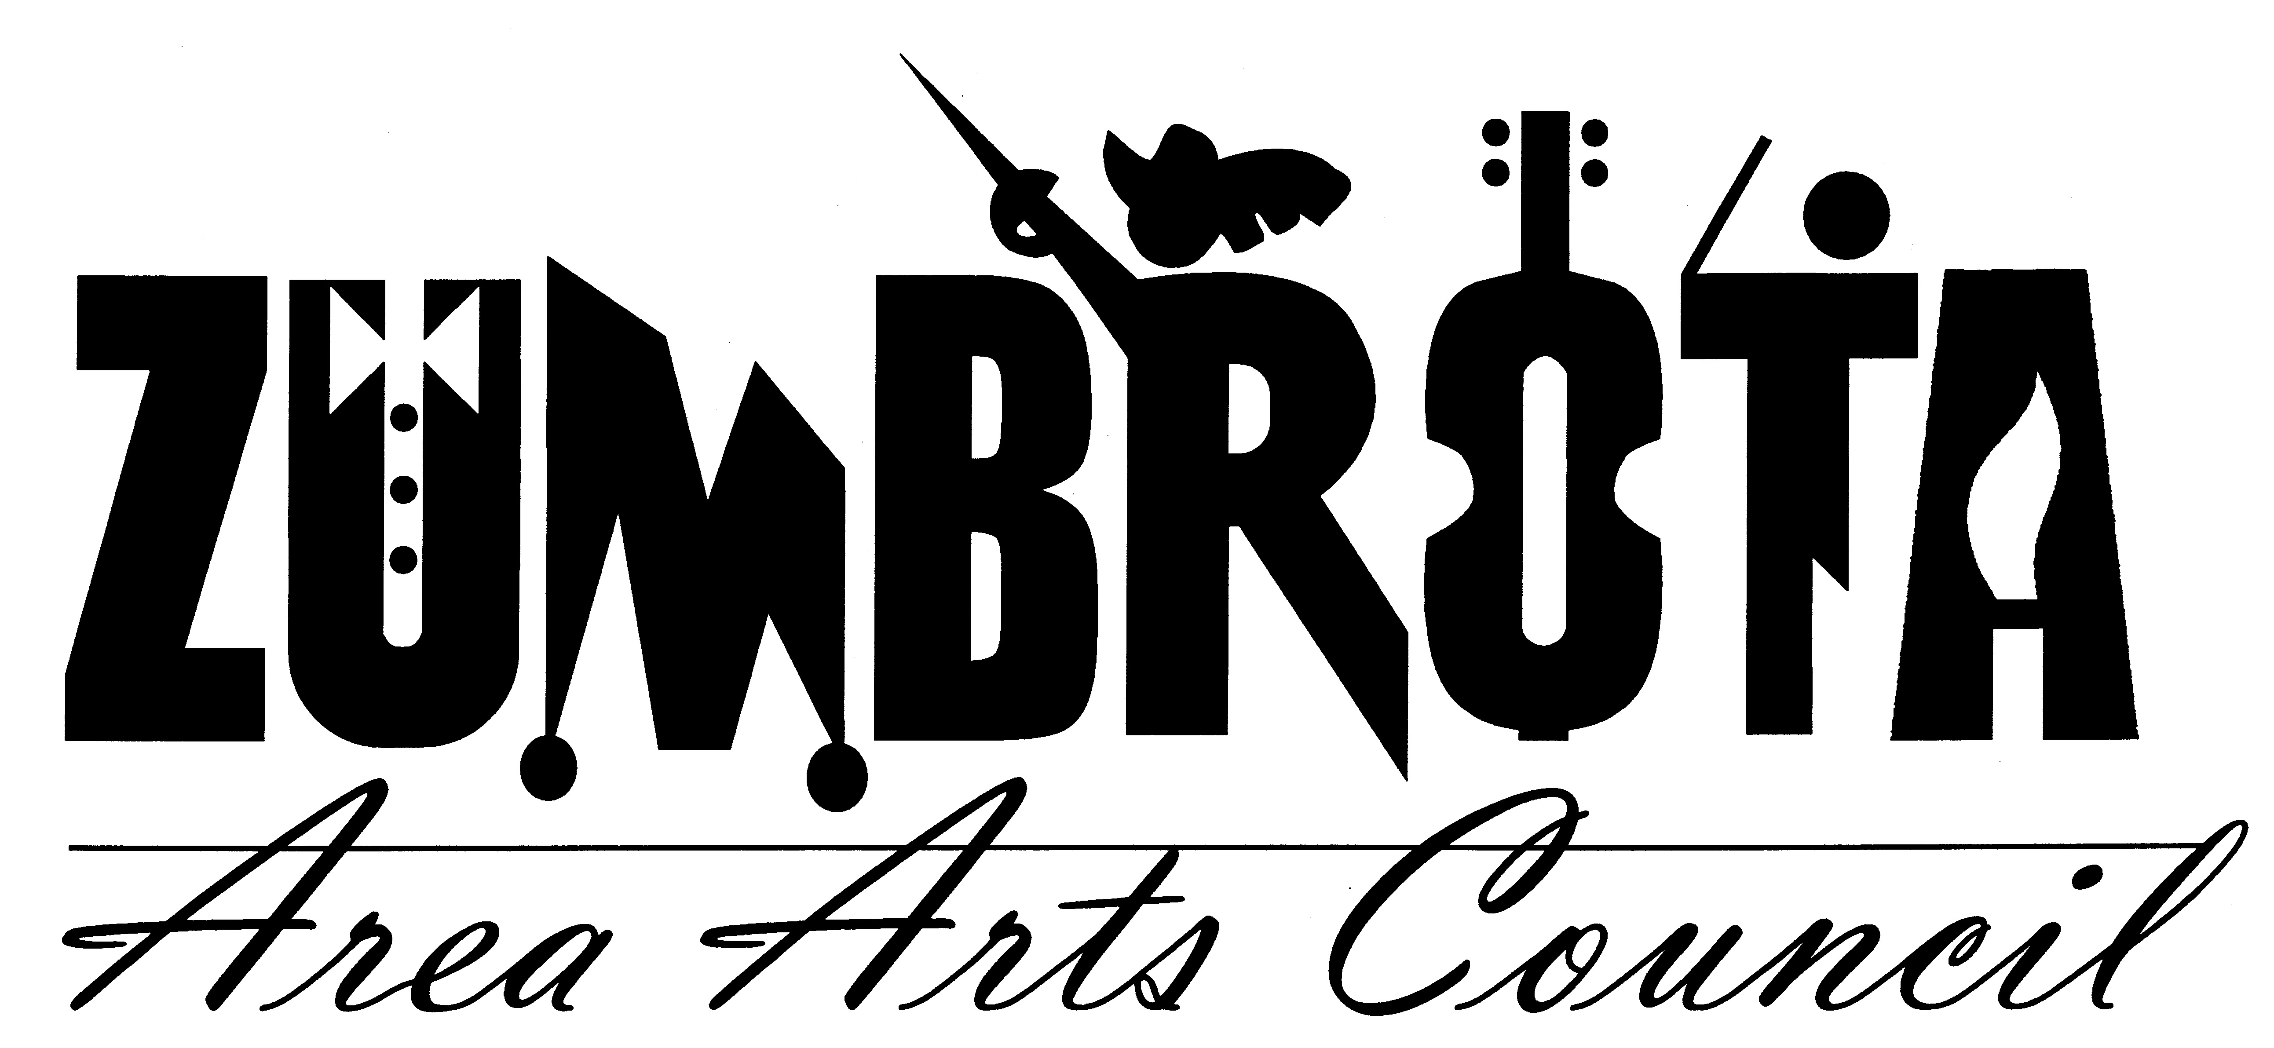
June 4, 2012 7:00 PM
Zumbrota Library
Meeting Minutes

In Attendance: Pam Shaw, Faye Joyner, Cheryl Hill, Allan Nilson, Dave Zimmerman, Marit Lomen, Bill Marx (arrived at 720pm)

Call to Order: President Pam Shaw called the meeting to order and welcomed everyone.

Agenda

ASCAP Fees & Sound System: Marie Marvin was unable to attend the meeting this evening. This issue was tabled until the next meeting.

Concert @ Everson Park: Marit received a request to help promote a concert at Lands Lutheran church. Marit will suggest the group use the usual advertising venues and ZAAC will gladly put the information on the website.
Art in East Park (June 16, 2012): The board members discussed the t-shirt and decided, and due to rising costs and other factors the board decided not to sell a T-shirt this year. Faye needed some help in the morning and several people volunteered to help. Allan will be there to help with heavy lifting in the afternoon.
Music in the Park (Starts June 12, 2012): Cheryl sent out about 100 letters to local businesses seeking sponsorship. Still short a few sponsors but have some outstanding requests from local business. Dave passed along the phone number for the Schwann’s delivery driver to ensure the Ice Cream gets delivered. Music in the Park will be advertised in the paper on Wednesday. Dave will get checks to Cheryl before the 12th.
State Theatre Director Interviews: 17 applications were received; phone interviews of top 7 candidates were held last week. 4 have been chosen for in person interviews the committee is interview 2 candidates each Wednesday the 6th and Sunday the 10th. We hope to have a recommendation for the board by next Monday the 11th. We scheduled another board meeting for Monday the 11th to hire a director.
Art Splash (September 8, 2012): Marit has the brochures done and will supply one to Cheryl for the website.
Membership Report: Bill had an updated list of members and has sent out the membership letters to all those new members from the phonathon. We do not have email address for the new members.
Financial Report: Dave had some financial information for the group. ZAAC has paid back the Hawley’s the 20k that we owned from the closing. Dave also filed ZAAC taxes.
State Theater: Dave has applied for property tax exemption, and that application failed. He is now working with Paul Rockne to resubmit the application. We take over the liquor license and insurance starting July 1st. Linda and Jeff smith are hosting a fundraiser for ZAAC on the 22nd. The Freewheelers will play at the theatre.
Officers: Board members voted in Bill Marx as Vice President and Cheryl Hill as Secretary.

Pam Shaw adjourned the meeting.

Respectfully submitted,
Cheryl Hill

