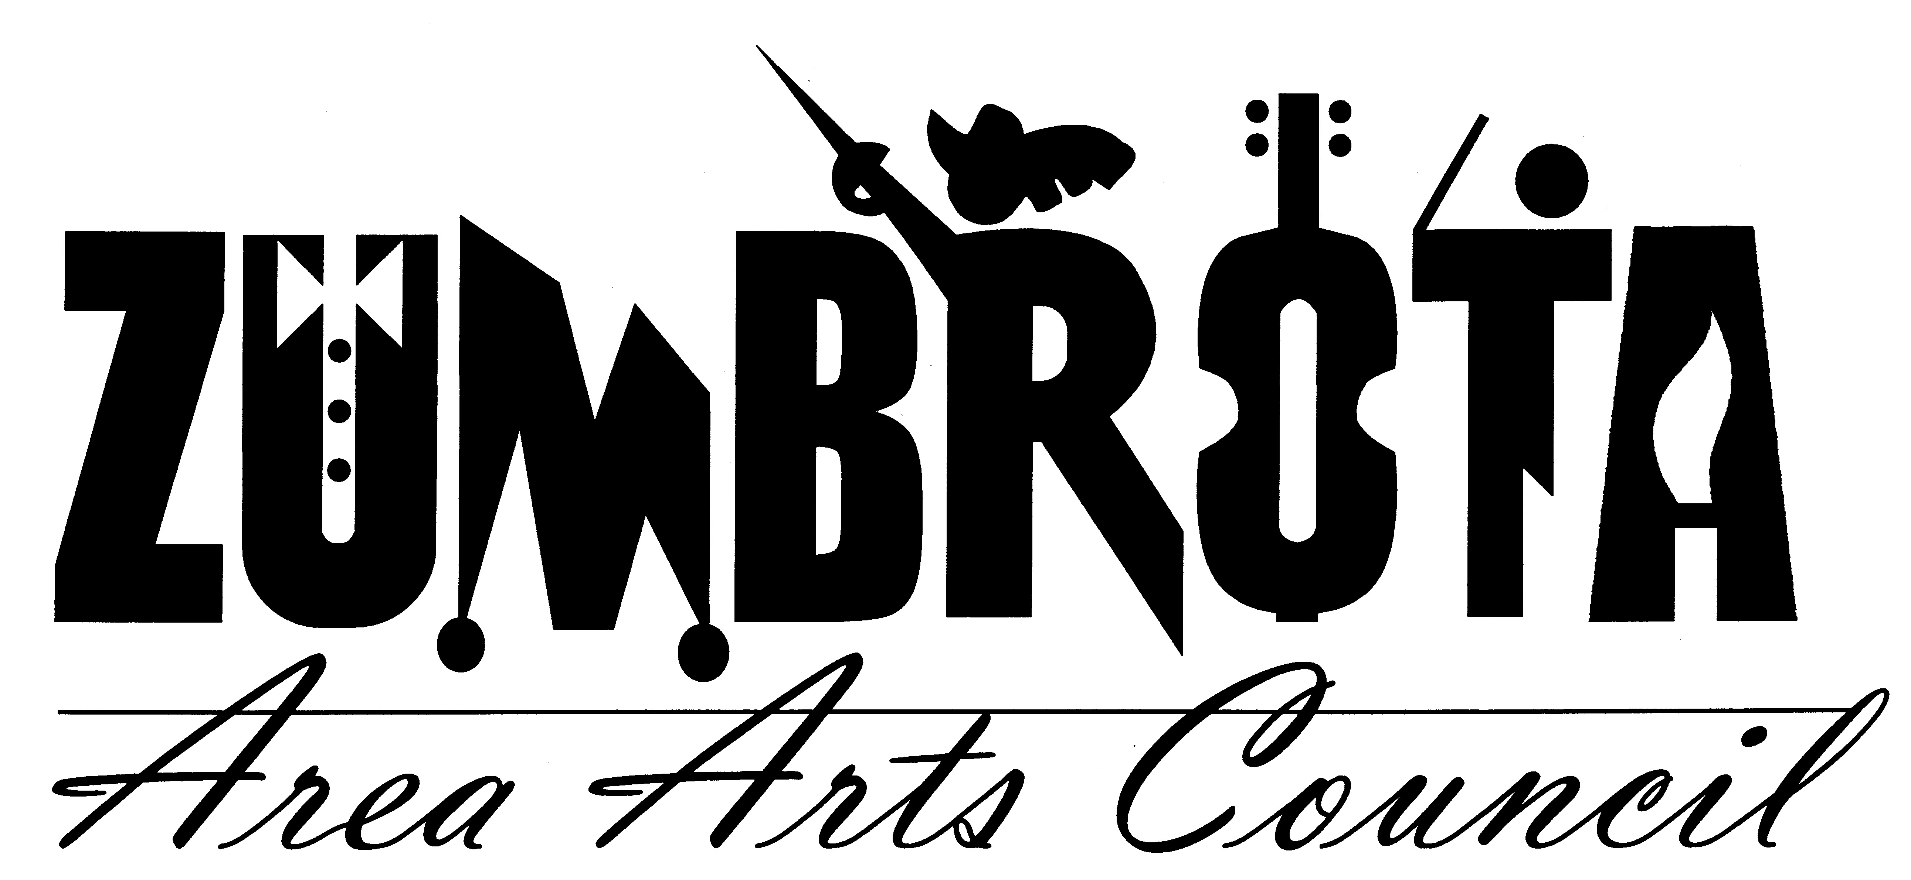
September 10, 2012 7:00 PM
State Theatre
Meeting Minutes

In Attendance: Pam Shaw, Faye Joyner, Cheryl Hill, Dave Zimmerman, Marit Lomen, Bill Marx, Joan Hellyer,

Call to Order: President Pam Shaw called the meeting to order.

Financial Report
Dave reported that there is $5623.14 in the regular ZAAC fund. There is $68, 420.00 in the Theatre fund.

Movie Committee
Roxanne Bartsh has formed a movie committee. They will meet Tuesday evening September 11. They will have a report for the October meeting.

Music in the Park
There are still 4 boxes of Ice Cream in the cooler. Cheryl has called our driver and asked him to remove them and refund if possible, but to no avail. She will try again.

Iron Pour
The tiles have been sold out and Joan is getting more. $1000 has been received and another $120 is yet to be paid for tiles. Joan has filled out the form for 80% of the grant payment from SELCO. She also asked for help creating posters for the event and needs help with the ZAAC tent and help breaking up iron and for cleanup the next day. Bridget’s is catering food and so is the Covered Bridge Restaurant. The Covered Bridge Restaurant will also be serving alcohol.

State Theatre
Ronda Sand sent a report to Pam Shaw who read the report to the group. Ronda discussed an incident at the State Theatre where an attendee tripped in the aisle and hit her head on a seat edge and cut it. Joan was on hand to offer some medical assistance. Ronda followed up with the women the next day and she needed a couple stitches. Dave reminded everyone that we have insurance to cover this sort of thing, Kalass insurance should be notified.

Ronda offered a few other updates. The main level bathroom will be made unisex for handicap accessibility for the time being. Hooks will be placed on both bathroom doors to ensure privacy. 2 chairs were removed from the theatre for the Forever Plaid show to make room for wheelchairs. Ronda has applied for a grant from the Zumbrota Community Trust for a laptop. The fire extinguisher was recently checked. SEMYO has been booked for February 1st to play alongside a silent film. Ronda is getting wireless internet installed. Workflow in the hallway and behind the bar was discussed. It was suggested that we simply meet to look at the possible locations for furniture.

Forever plaid reportedly went well. All shows were well attended and one even sold out. Cheryl will get a congratulations card for Z Theatre for the Board to sign. There was a discussion about the light level in the theatre as many attendees said they could not read the assigned seating numbers or their programs.

Membership
Bill reported that there are 74 regular members and 121 Encore members. Bill has sent out some more CDs. We will hold a membership meeting November 4th at 1pm. Joan will talk to Bridget’s about providing food. There will be door prizes and a movie will be shown as well.

Art Splash
Marit gave an update on Art Splash. Attendance was average. Next year she may consider doing it a different weekend in September. Over $3,000 brochures were sent out. It was advertised in Rochester women, Mayo source, in Post Bulletin events section and several places locally. There were 5-6 people for the 1pm tour and no one for the 11am tour of the State Theatre.

The meeting was adjourned at 8:45 pm.

Respectfully submitted,
Cheryl Hill

