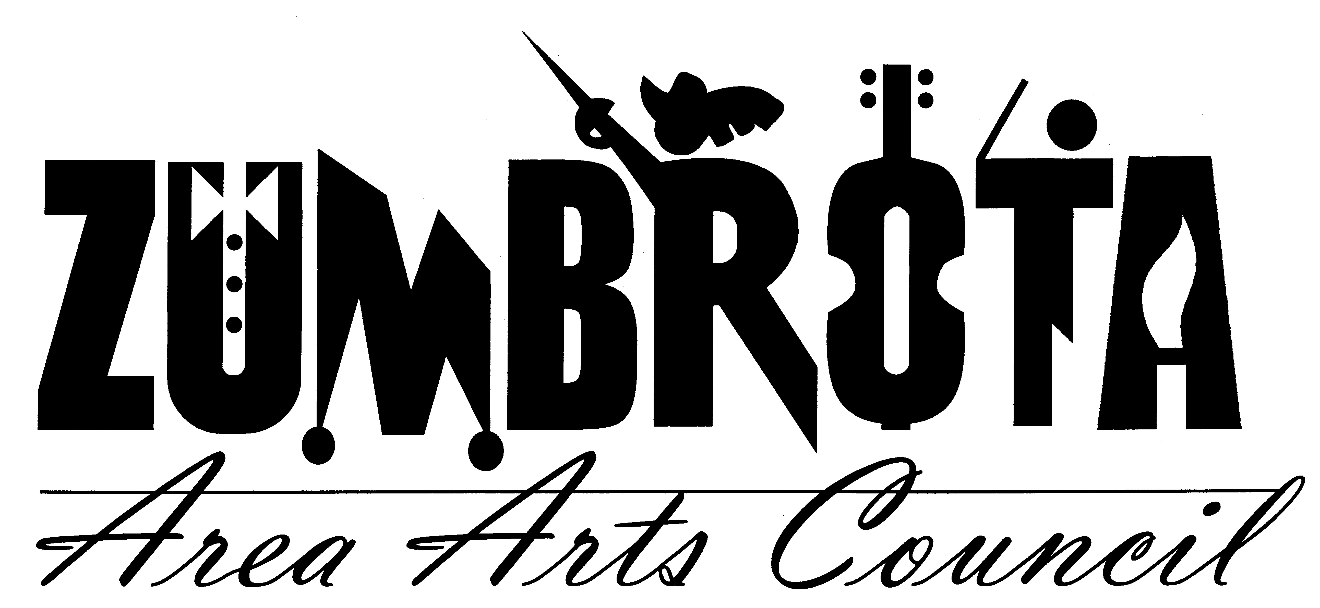
October 1st, 2012 7:00 PM
State Theatre- Meeting Minutes

In Attendance: Pam Shaw, Faye Joyner (left early), Cheryl Hill, Dave Zimmerman, Marit Lomen, Bill Marx, Joan Hellyer, Allan Nilson, Ronda Sand.
Call to Order: President Pam Shaw called the meeting to order at 7:00pm

Financial Report
Dave reported that there is $5023.92 in the regular ZAAC fund. There is $59, 033.31 in the Theatre fund. This is after $9,000 was paid to Chandler Roofing for the new roof. The total bid for the new roof from Chandler was $24,000. The $4,000 SEMAC Grant for operating funds was received.

Dave Zimmerman also announced he was resigning his position on the ZAAC board and as Treasures for ZAAC. The Board discussed a few options for succession planning. Dave will work to set up some simple checks and balances with future treasure and the Theatre Director.

Also at this time it was decided that due a conflict with another board member’s schedule Board meeting will be moved to 6:00pm.

Music in the Park
Cheryl talked to Schwann about ice cream pick and reimbursement; they said they have never picked up the excess ice cream and said it would be fine if it was left in the freezer all winter long.

Iron Pour
The 2012 Iron Pour happened on September 29th. Overall it was good event with a nice add in the Post Bulletin and over 200 people attending. Covered Bridge restaurant was happy with sales and turnout, haven’t heard from Bridget’s yet. Still an issue of excess iron that needs to be removed, and the iron that was “purchased” from the artists. There will be no iron 2013, but looking at same weekend 2014. There was some question about the history of Iron Pours/Art Splash, Merit said she would look through her notes and send information out to the group. Many tours of the theatre were given .

State Theatre
Ronda sent a Theatre report to the board. The group discussed the issue of ticket sales for parties renting the theatre. If a group wants to the rent the theatre and show a movie, they must pay for the copyright. The Board discussed a request to use the theatre to show the movie 2016. The requested date is already booked for another event. The group would need to pay the public performance fees and get a DVD to show. Ronda will follow up with this group to see if they have another date in mind, and or have the movie in the proper format with public performance license.

Membership
Bill has sent out Sept. letters. Joan and Bill will work on membership meeting via email, the meeting will be on November 4th. Marit will help with the postcards, Ronda and Cheryl will help with a movie.

The meeting was adjourned at 8:00 pm.

Respectfully submitted,
Cheryl Hill

